1. Introduction

Data Report

Introduction
This Data Management Plan outlines how data was collected, prepared, transformed and stored to be used within the sun safety and skin cancer protection space. This project was designed to help users make safer decisions before engaging in sun tanning or general UV exposure by providing useful tools based on the Fitzpatrick skin type model. These tools in essence estimate the time it takes to contract a sun burn, provide a UV index awareness and skin-type specific risk indicators to promote sun protection guidance. In addition to these protective tools, it also contains an educational aspect which presents various data in a digestible manner to teach the user. About skin cancer rates and dangers across Australia for different demographics.
The data management plan is a live document that supports system design and iterative development. It explains the origin and purpose of these datasets, the processes used to clean and transform them and the methods used to load the datasets into the system. It also serves as a guideline that addresses the ethical concerns regarding data collection and the relevant use of open data within the digital health context.

Data Management Plan

Key Data management practices include:
- Collection of Open datasets relevant to UV risk, skin type and skin cancer rates
- Cleaning and standardised raw data in uniform formats
- Transformation to SQL compatible data structures
- Storing Processed data in mysql databases
- Using models to support application functionality
- Considering ethical, legal and privacy issues

Open Data Sources:

D’Orazio, J., Jarrett, S., Amaro-Ortiz, A., & Scott, T. (2013). UV radiation and the skin. International Journal of Molecular Sciences, 14(6), 12222–12248. https://doi.org/10.3390/ijms140612222
Australian Institute of Health and Welfare. (2025, October). Cancer data in Australia. https://www.aihw.gov.au/reports/cancer/cancer-data-in-australia/data?&page=2.
Australian Government Cancer Australia. (2025, December 18). Melanoma of the skin statistics. https://www.canceraustralia.gov.au/. https://www.canceraustralia.gov.au/cancer-types/melanoma-skin/melanoma-skin-statistics?utm_source=chatgpt.com

Open Data Source Table

Names | Granularity | Physical Access | Source Link
UV_skin | Fitzpatrick Skin Type | .xlsx to .sql | https://doi.org/10.3390/ijms140612222
Territory | Territory and year level | .xlsx to .sql | https://www.aihw.gov.au/reports/cancer/cancer-data-in-australia/data?&page=2
Age | Age group level | .xlsx to .sql | https://www.aihw.gov.au/reports/cancer/cancer-data-in-australia/data?&page=2
Gender | Year and Gender Level | .csv to .sql | https://www.canceraustralia.gov.au/cancer-types/melanoma-skin/melanoma-skin-statistics?utm_source=chatgpt.com

Data Wrangling

First, the datasets were imported into Python using the Pandas library. The project used three different datasets containing information about cancer cases in Australia by territory, age group, and gender. The files were loaded from Excel and CSV formats using the read_excel() and read_csv() functions.
Once loaded, the column names were standardized to ensure consistency across the datasets. This involved removing extra spaces and line breaks in column names to prevent referencing errors during analysis.
Next, the datasets were cleaned to ensure that the variables used in the analysis were in the correct format. For example, the Year and Count columns were converted to numeric values to allow aggregation and statistical analysis. Any invalid values were automatically converted to missing values using errors='coerce'.
Additional filtering was applied to remove aggregated categories that could distort the analysis. For example, rows labeled “Australia” were removed from the territory dataset so that the analysis focused only on individual states and territories. Similarly, the “All ages combined” category was removed from the age dataset to ensure that the analysis only considered specific age groups.
After cleaning the data, grouping and aggregation operations were performed. Using the groupby() function in Pandas, the datasets were summarized to calculate statistics such as:
- Total cases by year and territory
- Average number of cases per territory
- Average number of cases by age group
- Average number of cases by gender
These transformations allowed the data to be used for key performance indicators (KPIs) and visualizations in the dashboard.

Data Modelling
The data model for this project was designed to support the analysis of UV exposure, sun protection behaviour, and sunburn risk across different demographic groups. A relational database structure was selected because it provides a clear and efficient way to organise related data entities while maintaining consistency, reducing redundancy, and supporting future scalability of the application.
At the centre of the model is the Response entity, which acts as the main table linking user-related demographic and contextual information. This table connects to the Age_group, Gender, and Location entities through foreign keys, allowing the system to associate each response with a particular age category, gender, and geographical location. This structure supports meaningful segmentation of users and enables the application to generate more personalised insights.The model also integrates environmental and behavioural factors. The UV_Level entity stores UV index information, the recorded date, and a corresponding risk level. This allows the system to represent the environmental context in which sun exposure occurs. The Sun_behaviour entity then links a response to a UV level and records whether the user applied sunscreen, wore a hat, wore protective clothing, or sought shade. This relationship is important because it enables the system to analyse whether protective behaviours are being used under different UV conditions.
The sunburn_event entity captures the outcome of exposure by recording whether a sunburn occurred, along with its severity and event date. This makes it possible to connect demographic information, environmental risk, and protective actions with a measurable health-related outcome. As a result, the model supports analysis of patterns such as which groups are more vulnerable, whether certain protective behaviours reduce sunburn severity, and how location and UV conditions influence user risk.From a modelling perspective, the design applies normalisation principles by storing demographic and contextual categories in separate entities rather than repeating the same values in one large table. This improves data integrity, reduces duplication, and makes updates easier to manage. For example, age groups, gender categories, and locations only need to be defined once and can then be referenced across multiple responses. This is especially important for future expansion, such as adding more user responses, integrating additional behavioural variables, or including new data sources related to weather or health outcomes.
The model was also designed with future application needs in mind. Although the current project uses mainly open and aggregated datasets for analysis and educational purposes, the ERD reflects how the system could evolve into a more interactive application where users enter their own details and receive personalised sun safety guidance. In that sense, the conceptual model not only supports the current iteration but also provides a scalable structure for future development.Overall, this data model is appropriate for the problem domain because it captures the key relationships between who the user is, where they are located, what UV conditions they are exposed to, what protective actions they take, and what outcome occurs. This makes the model both logically consistent and practically useful for supporting the goals of the sun safety application.
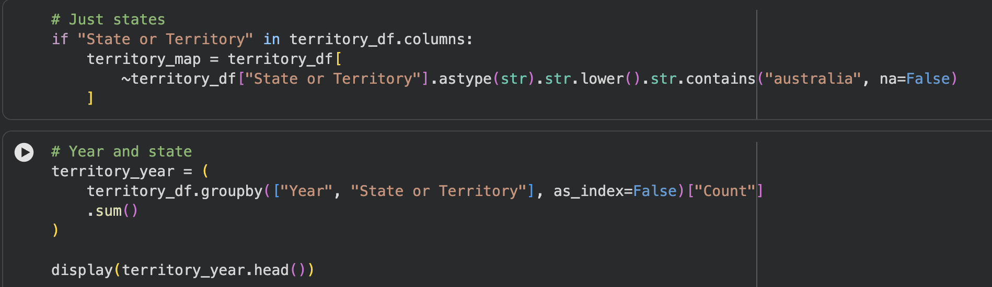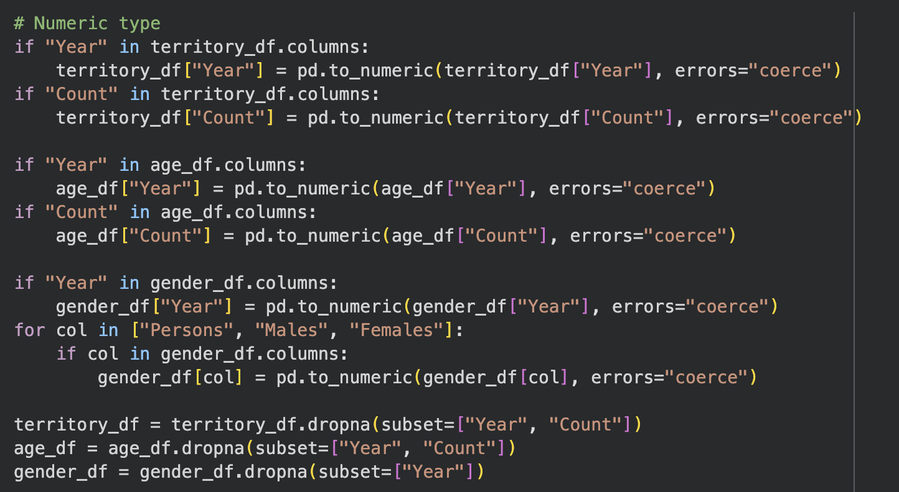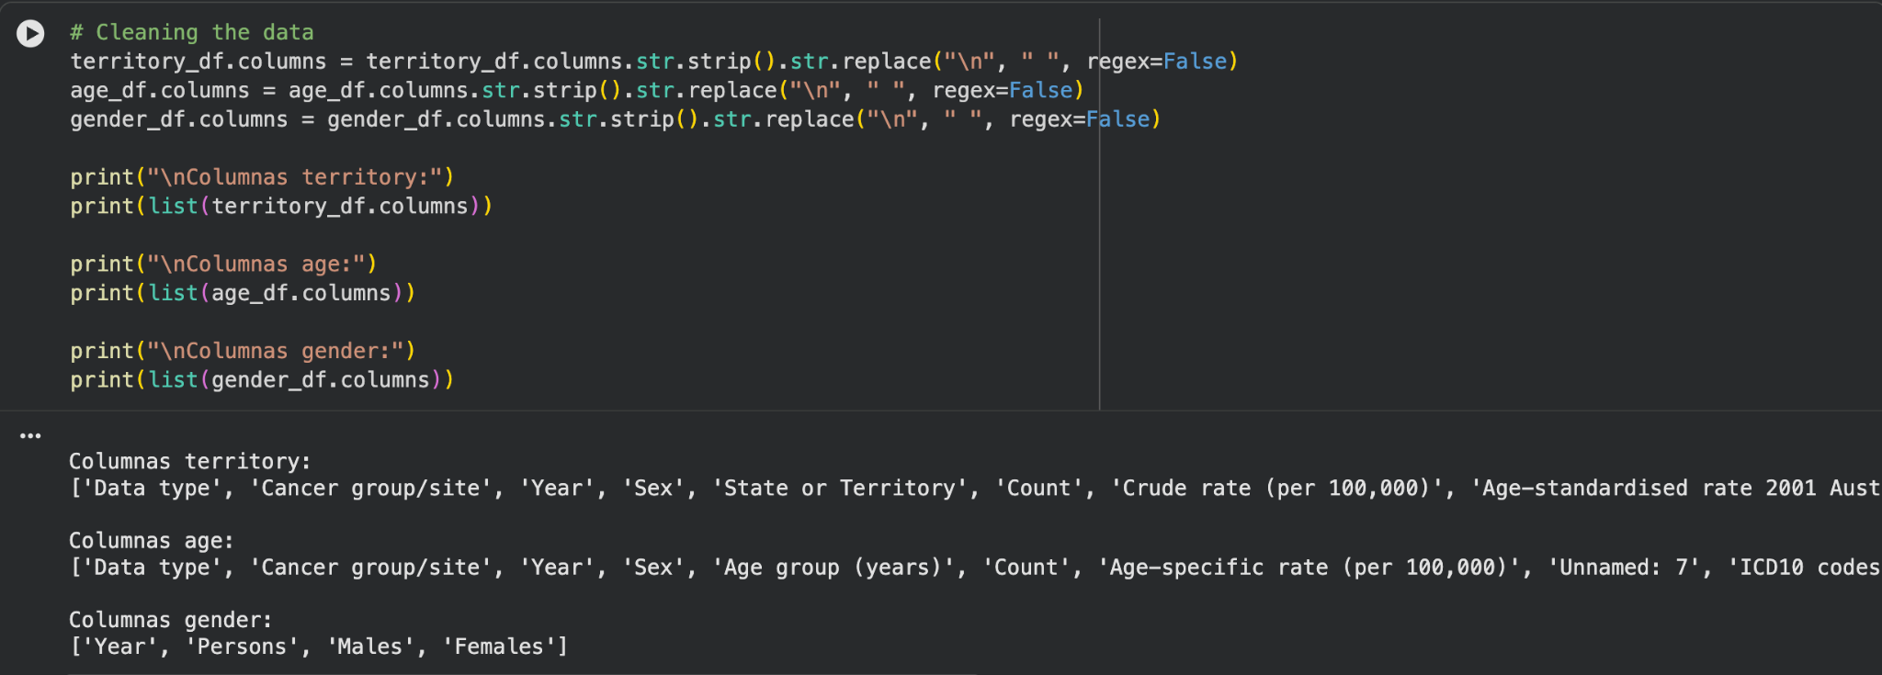

Data Storage and Archiving
The datasets were stored in Github in SQL file format. These formats were chosen because they are widely supported, easy to process in Python, and suitable for tabular data.
During the analysis process, the datasets were loaded into memory using Pandas DataFrames. The cleaned and transformed datasets were stored within the Python environment to support further analysis and visualization.
To ensure reproducibility and data integrity, the analysis workflow was documented within a Google Colab notebook. This notebook contains the complete sequence of steps used for data wrangling, cleaning, aggregation, and visualization. By storing both the code and the analysis in a single environment, it is possible to reproduce the results at any time.
For archiving purposes, the original raw datasets were preserved separately from the processed data. This ensures that the original data remains unchanged and can be referenced if further validation or analysis is required in the future.
Additionally, the project files and analysis scripts can be stored in a version-controlled environment or cloud storage to ensure long-term accessibility and backup.

Database Relationship Diagram
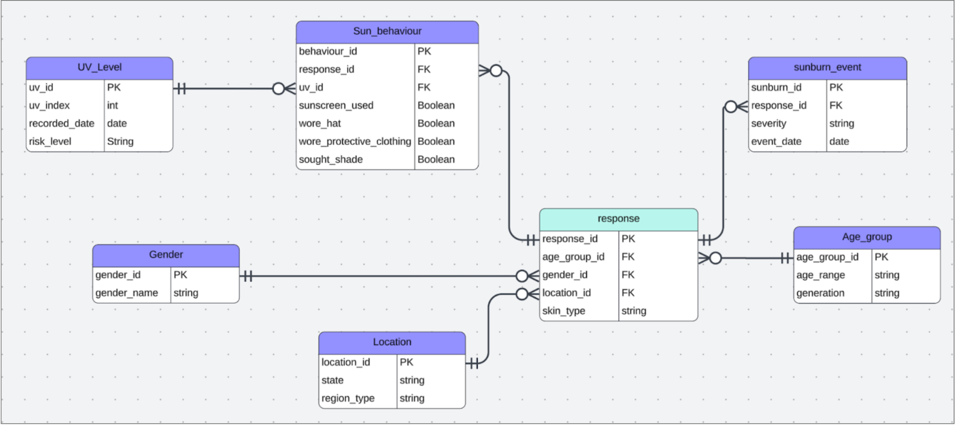

Demographic Entities

Age Group
The Age_group entity stores information about different age categories.
Attributes include:
- age_group_id (Primary Key)
- age_range
- generation
This entity allows the system to analyse how UV exposure and sunburn risk vary across different age groups.

Gender
The Gender entity records the gender classification of users.
Attributes include:
- gender_id (Primary Key)
- gender_name
This table supports demographic analysis of sunburn risk between genders.

Location
The Location entity stores geographical information about where the user is located.
Attributes include:
- location_id (Primary Key)
- state
- region_type
This entity enables the system to analyse how sun exposure and UV risks vary across different regions and states.

Ethical Issues

The project raises a few ethical considerations because it provides health related guidance to the user and uses demographic public health data. Although the application is not intended to diagnose medical conditions the users may interpret the information such as burn time skin cancer risk or SPF recommendations as authoritative advice. For this reason the application should present itself as educational and supportive rather than medical.

Secondly the Fitzpatrick skin type model although widely used in the scientific community may not fully represent the complexity and diversity of all skin tones and lived experiences therefore the system should avoid implying that it is universally complete or perfectly precise.

Lastly it is important to note that the public health data may contain inconsistencies or biases reflecting on how different demographic groups are categorised and recorded proportionately. It is important to point out these limitations rather than presenting the data as completely neutral or comprehensive.

Legal Issues

The legal issues in this project mainly relate the use of open data and various conditions that may be attached to each source since this application uses public datasets it is important to identify the source of each data set, how it was accessed and any modification or transformation that occurred to render the data set usable in application. The final report must then include sales details and copyright or licensing information if necessary for each data set if the data set was transformed into new formats the report should also state that the modifications were made for system compatibility and analytically use and that any modification to the data was for compatibility purposes.

Privacy issues
current datasets used in the project are aggregated and contain non identifiable data points which reduces the risk of privacy infringement. The age, gender and territory datasets describe population level skin cancer trends rather than individual records and the UV skin data set functions as a reference table for educational purposes rather than a collection of personal data.

This strength is not friable in the application however for future versions it could become a risk if the application opts to store user entered information such as location skin type and sun exposure patterns for this reason the system should only retain user data where absolutely necessary for functionality.

Future needs and potential changes

This project must also consider future needs and possible data related challenges. One possible challenge is the integration of datasets with different structures and purposes as well as various levels of granularity. The UV skin data set is a small reference data set whilst the age gender and territory datasets describe large scale demographic trends if these datasets were to be collated it would require careful modelling and data design.

Another challenge presented is that some datasets such as the Fitzpatrick reference information may remain stable for long periods whilst public health statistics and UV data may change more frequently the system must therefore define how and when data updates will occur and how to integrate live datasets if the application opted for that path.

A final challenge is ensuring consistency between the conceptual ERD and the physical datasets currently available whilst the herds represent planned future functionality the currently ingested data may slightly differ as this may be acceptable for an iterative project it should be explained clearly in the report for future versions or updates.

5. Data Wrangling, cleansing and storing
D

6. Data Modelling

7. Screenshots and Database Relationship Structure

